Modelling the Impact of Reduced Fishing and Poaching Effort within the Commercial Line Fishery on Macrobenthic Communities of the Thukela River
Introduction
This study aims to investigate the effects of reduced fishing and poaching by the commercial line fishery on the biomass of macrobenthic ecosystem components along the Thukela River banks. The objective is to simulate scenarios of reduced activity in the commercial line fishery by 50%, 25%, and 0%, and observe the resulting biomass trends. This is carried out using the Thukela Bank model (Ayers et al. 2013), where both fishing effort and fishing mortality of the commercial line fishery are proportionally reduced to reflect legal restrictions and simulated poaching scenarios. The model runs over the period 1990 to 2040.
Methods
The study was conducted using Ecopath with Ecosim (version 6.5) and the Thukela Bank 1990 model. The dataset used covered the period from 1990 to 2009 (Ayers et al. 2013). Upon loading the model, all parameters were checked for completeness. Where data were missing, the software generated estimates based on known parameters.
The simulation was based on the Average Biomass (AVG B) scenario, which incorporates the average biomasses calculated from original measurements for each functional group in the model. To implement the fishing and poaching reduction scenarios, adjustments were made to both the fishing effort and fishing mortality parameters for the commercial line fishery.
Fishing effort in this study was modified using the "Fishing Effort" tab within the Ecosim module, specifically targeting the commercial line fishery fleet. The baseline scenario was established by running the model without any changes to fishing effort or fishing mortality rates, utilizing data collected from 1990 through the end of 2008, which corresponds to the full period for which observational data were available for the fishery.
In the second scenario, fishing effort values were maintained at historical levels from 1990 to 2008 to accurately reflect the empirical dataset. From 2009 to 2014, fishing effort was reduced by 50%, and from 2014 to 2019, it was further reduced by 25%. These gradual reductions were implemented in two steps to observe any ecosystem changes resulting from decreased fishing pressure, enabling the assessment of potential recovery trends or shifts in community structure as fishing intensity declined.
From 2019 onward, fishing effort was set to zero to simulate the establishment of the Thukela Bank as a Marine Protected Area (MPA), which led to the complete cessation of commercial fishing activity in the area.
Similarly, fishing mortality rates were adjusted in the "Fishing Mortality" tab for all organisms impacted by the commercial line fishery, including large pelagics, small pelagics, benthopelagic carnivores, benthopelagic biomass, and benthic biomass. These mortality rates were reduced by the same percentages and over the same time intervals as the effort reductions, in order to simulate the effects of poaching alongside legal reductions in fishing.
After implementing the changes, the Ecosim model was run to simulate biomass responses from 1990 to 2040. Graphs representing the modified fishing effort and the resulting biomass trends of the macrobenthic components were captured to illustrate the impact of the simulated scenarios.
Results
The results were obtained by running the Thukela Bank ecosystem model to simulate reduced commercial line fishery activity from 1990 to 2040. Fishing effort was gradually reduced in stages: maintained at historical levels until 2008, reduced by 50% (2009-2014), further reduced by 25% (2014-2019), and set to zero from 2019 onward to simulate marine protected area establishment. Corresponding fishing mortality reductions were applied to all targeted species, and the resulting biomass responses of six macrobenthic components were analysed.
The Ecosim simulations showed that reducing fishing and poaching effort in the commercial line fishery had little effect on the biomass of macrobenthic components along the Thukela River. As seen in Figure 1, fishing effort was gradually decreased from 2009 and set to zero from 2019, reflecting the creation of the Thukela Marine Protected Area (MPA). Despite these reductions, Figure 2 demonstrates that the biomass of macrobenthic groups, including cephalopods, adult and juvenile prawns, commercial crustaceans, carnivorous benthos, and detritivorous benthos, remained almost unchanged throughout the simulation period.

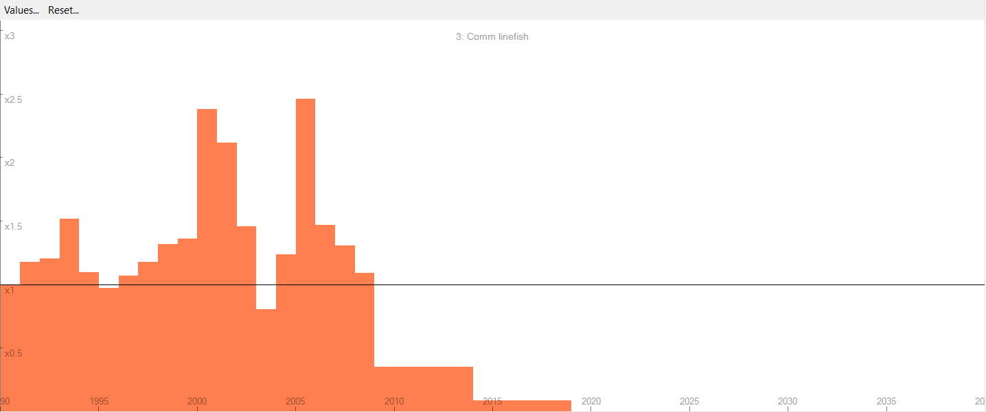
Figure 1: Commercial line fishery effort reduction scenario (1990-2040)
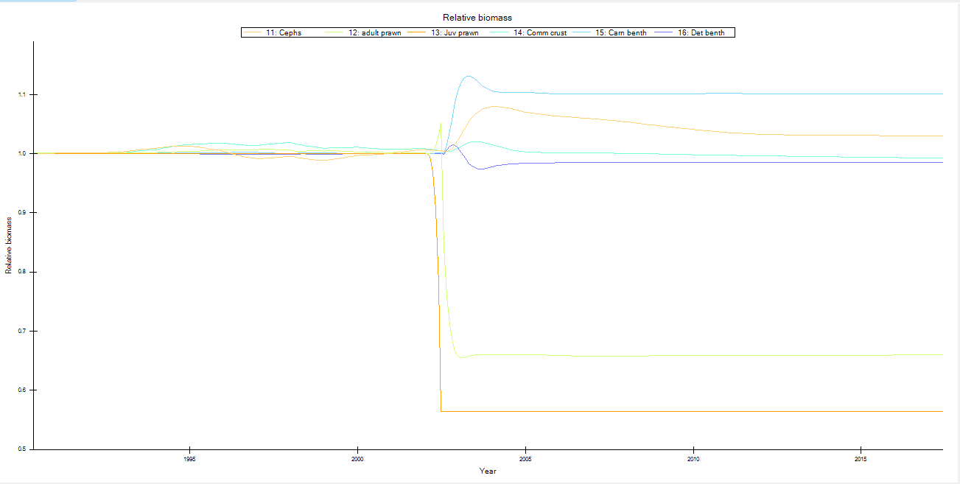
Figure 2 Macrobenthic biomass trends under reduced commercial line fishing pressure
This lack of response can be explained by the low impact of the commercial line fishery on these groups. As indicated in Table 1, the total catch by the commercial line fishery was 0.030985 t/km²/year, which is small in comparison to the total catch across all fleets (0.68356 t/km²/year). This suggests that the commercial line contributes only a small fraction of the total fishing pressure in the ecosystem.
Furthermore, the specific organisms caught by the commercial line fishery, large pelagics, small pelagics, benthopelagic carnivores, benthopelagic biomass, and benthic biomass, do not appear to have a strong trophic link to the macrobenthic components. This is supported by the dietary composition data in Table 2, which shows that macrobenthic components make up only a minor proportion of the diet of these targeted species.
Therefore, the negligible changes in macrobenthic biomass can be attributed to both the limited direct fishing pressure exerted by the commercial line fishery and the weak trophic interactions between its targeted species and the macrobenthic groups.

Table 1 Commercial line fishery catch compared to total fleet catches (t/km²/year)
 | Group name | Comm linefish | Total catch (t/km²/year)
6 | Lg pels | 0.010748 | 0.011652
7 | Sm pels | 1.00E-07 | 0.036422
8 | Benthopel carn | 0.020186 | 0.160743
9 | Benthopel bi | 5.06E-05 | 0.152721
10 | Benthic bi | 1.00E-07 | 0.020516
 | Total catch | 0.030985 | 0.68356

Table 2 Diet composition matrix showing trophic interactions between commercial line fishery targets and macrobenthic components
 | Name | 6 | 7 | 8 | 9 | 10 | 11 | 12 | 13 | 14 | 15 | 16
6 | Lg pels | 0.042 | 0 | 0 | 0 | 0 | 0 | 0 | 0 | 0 | 0 | 0
7 | Sm pels | 0.15 | 0 | 0 | 0 | 0 | 0 | 0 | 0 | 0 | 0 | 0
8 | Benthopel carn | 0.071 | 0 | 0 | 0 | 0 | 0 | 0 | 0 | 0 | 0 | 0
9 | Benthopel bi | 0.55 | 0 | 0.77 | 0.010495 | 0.01 | 0.347 | 0 | 0 | 0 | 0 | 0
10 | Benthic bi | 0 | 0 | 0 | 0.056 | 0.01 | 0 | 0 | 0 | 0 | 0 | 0
11 | Cephs | 0.042 | 0 | 0 | 0 | 0 | 0.001 | 0 | 0 | 0 | 0 | 0
12 | adult prawn | 0 | 0 | 0.17 | 0.205646 | 0.05 | 0 | 0.005 | 0 | 0.01 | 0 | 0
13 | Juv prawn | 0 | 0 | 0 | 0 | 0 | 0 | 0 | 0 | 0 | 0 | 0
14 | Comm crust | 0 | 0 | 0 | 0 | 0 | 0.179 | 0 | 0 | 0.005 | 0 | 0
15 | Carn benth | 0.014 | 0.09 | 0.04 | 0.511 | 0.606 | 0.2445 | 0.29 | 0 | 0.108 | 0.05 | 0
16 | Det benth | 0 | 0.01 | 0.02 | 0.217 | 0.277 | 0.2285 | 0.355 | 0 | 0.655 | 0.386 | 0

Conclusion
The findings show that simply reducing commercial line fishing and poaching won't make much difference to the bottom-dwelling creatures in the Thukela River, mainly because this type of fishing doesn't directly affect them and there aren't strong food web connections between them. Moving forward, researchers need to do a better job of tracking and understanding poaching activities so they can build more accurate models of how the ecosystem works. More importantly, managers can't just focus on one type of fishing - they need to look at the bigger picture and consider how all the different fishing activities combined are affecting these important seafloor communities if they really want to protect the Thukela Marine Protected Area.

References
Ayers, M. J., Scharler, U. M., & Fennessy, S. T. (2013). Modelling ecosystem effects of reduced prawn recruitment on the Thukela Bank trawling grounds, South Africa, following nursery loss. Marine Ecology Progress Series, 479, 143–161.

